Week 1 –

- Screen Shot
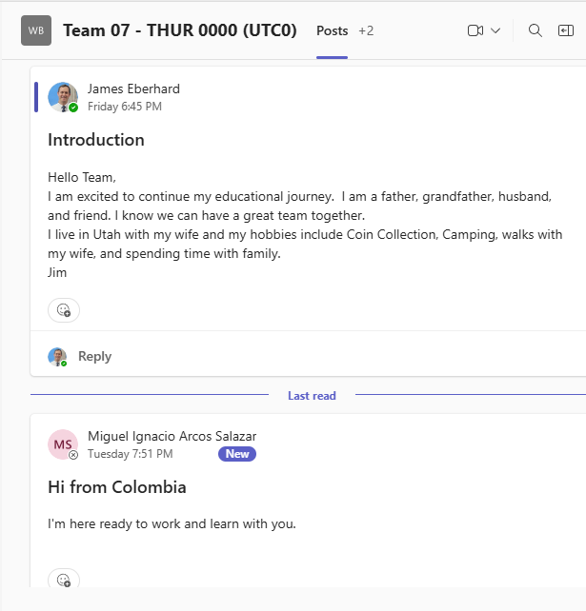

2 - Group Name – Team 7
3 – Meeting time – 5:00 PM MST which is Thurs 0:00 UTC
4 – Keith Eberhard is the Group leader for week 2

